**Task 1: Network Mapping with Nmap**

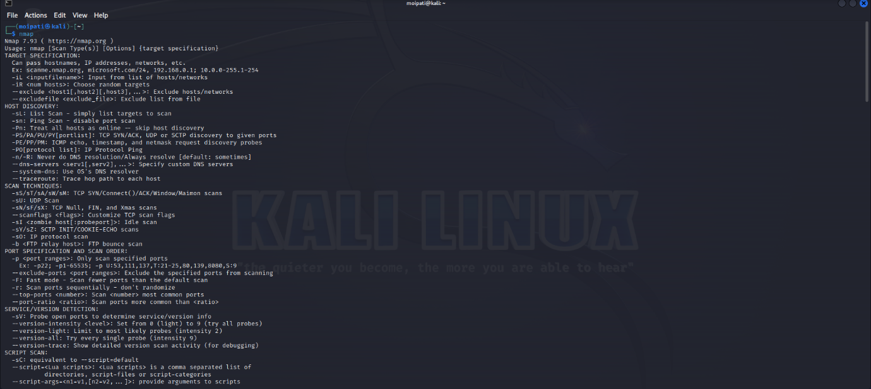(nmap is already preinstalled so here are all of the details)

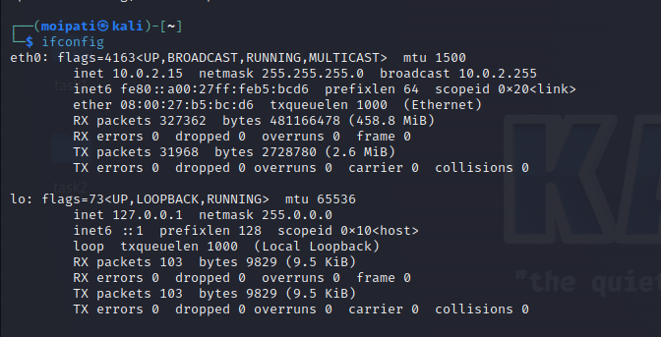

(check range of the ip addresses in my network)

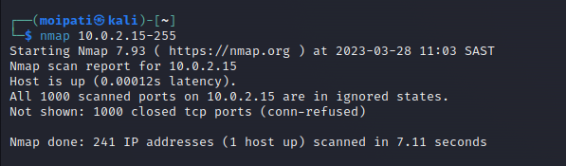

(scan all of the ip addresses in the range)

(network map based on the scan)

**Task 2: Network Packet Analysis**

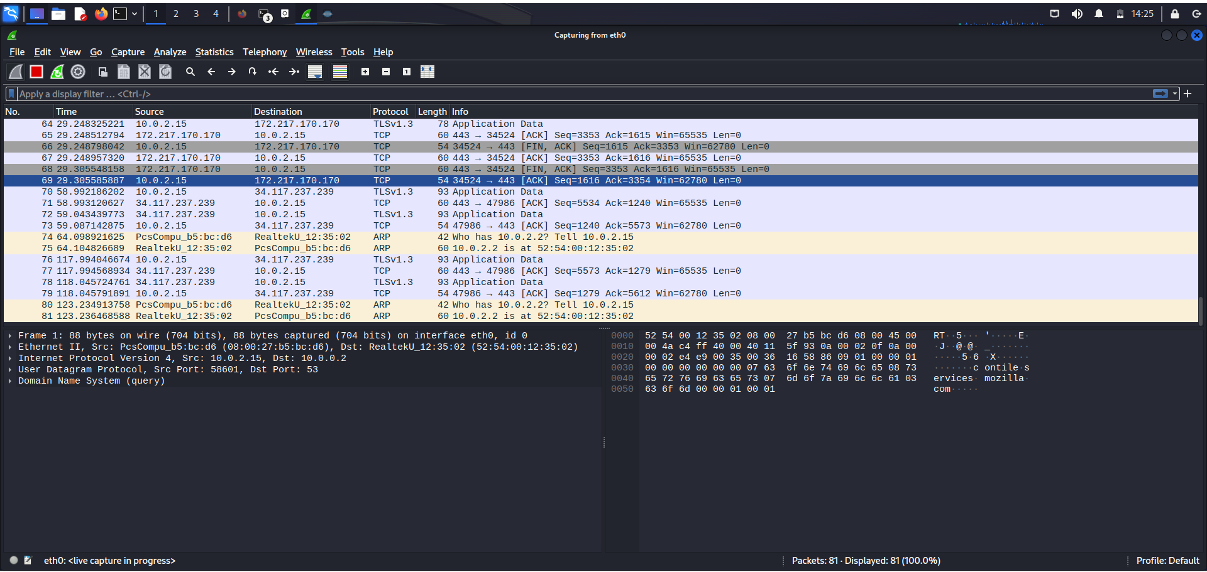(capture packets on wireshark)

After analysing the packets that wireshark has captured there are a few things that I have noticed. There were 2 packets that are grey, these are TCP packets and they represent a TCP handshake. The yellow packets are the traffic that is being routed. The purple packets are the TCP packets that are the TCP traffic. There are currently no potential security threats that I can identify.

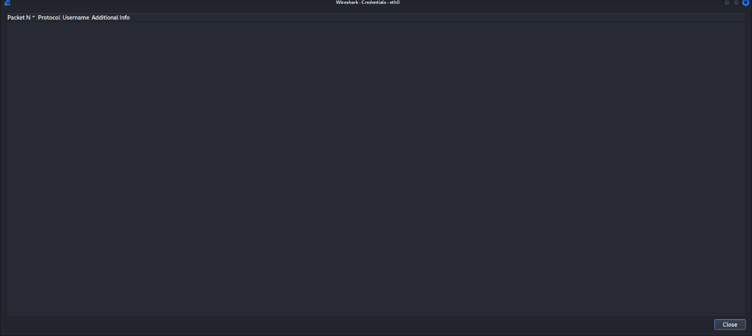

Unfortunately I was unable to extract the username and password from the wireshark tools credential tab. There are multiple ways that the security of the network can be improved. The first way to improve the network security would be to limit network access, too many people on the network could leave the network vulnerable. The passwords should be regularly updated, Another way to improve the security would be to install a firewall, firewalls make it difficult for hackers to gain access to the system. Another way to improve the security would be regularly update the software, not updating the software regularly can open up new vulnerabilities that hackers could exploit.